Exercise -1 Implementing the singleton pattern

class Database {

// Step 1: Create a private static object
private static Database instance;

// Step 2: Make the constructor private
private Database() {
System.out.println("Database object created.");
}

// Step 3: Public static method to get the single object
public static Database getInstance() {

// Create the object only if it doesn't already exist
if (instance == null) {
instance = new Database();
}

return instance;
}

// A normal method
public void connect() {
System.out.println("Connected to Database.");
}
}

public class Main {

public static void main(String[] args) {

// First object
Database db1 = Database.getInstance();
db1.connect();

System.out.println();

// Second object
Database db2 = Database.getInstance();
db2.connect();

System.out.println();

// Third object
Database db3 = Database.getInstance();
db3.connect();

System.out.println();

// Compare references
System.out.println("db1 == db2 : " + (db1 == db2));
System.out.println("db2 == db3 : " + (db2 == db3));
System.out.println("db1 == db3 : " + (db1 == db3));
}
}

Output
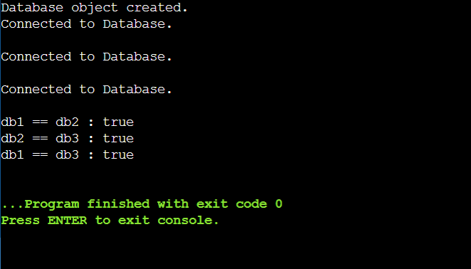

Exercise -2 Implementing the factory method pattern

// Step 1: Create an interface

interface Vehicle {
void start();
}

// Step 2: Implement the interface

class Car implements Vehicle {

@Override
public void start() {
System.out.println("Car is starting...");
}
}

class Bike implements Vehicle {

@Override
public void start() {
System.out.println("Bike is starting...");
}
}

class Truck implements Vehicle {

@Override
public void start() {
System.out.println("Truck is starting...");
}
}

// Step 3: Create the Factory Class

class VehicleFactory {

public Vehicle getVehicle(String vehicleType) {

if (vehicleType == null) {
return null;
}

if (vehicleType.equalsIgnoreCase("Car")) {
return new Car();
}

else if (vehicleType.equalsIgnoreCase("Bike")) {
return new Bike();
}

else if (vehicleType.equalsIgnoreCase("Truck")) {
return new Truck();
}

return null;
}
}

// Step 4: Main Class

public class Main {

public static void main(String[] args) {

VehicleFactory factory = new VehicleFactory();

Vehicle vehicle1 = factory.getVehicle("Car");
vehicle1.start();

Vehicle vehicle2 = factory.getVehicle("Bike");
vehicle2.start();

Vehicle vehicle3 = factory.getVehicle("Truck");
vehicle3.start();
}
}

Output
